CS147 HW3

Keonwoong Min

1. Assume a word addressable memory and a register file on a computing system contains the following data at an instance of time during running of a program. What is the operand value retrieved if : [ **5*5pts** = **25pts**]

a. Next instruction is direct addressing with memory address 0x10003010?

b. Next instruction is indirect addressing with memory address 0x10003010?

c. Next instruction is register addressing with register address 7?

d. Next instruction is register indirect addressing with register address 7?

e. Next instruction is displacement addressing

ANS)

1. Since it is direct addressing and the address is 0x10003010, its content in the memory is 0x10003014.

So, the answer is 0x10003014

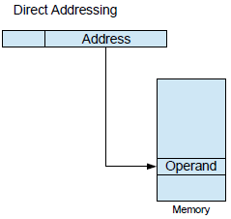

1. Since the instruction is indirect addressing the memory has the address of the operand. Instruction address is 0x10003010, and the content of this address is 0x10003014.

The content of the address 0x10003014 in the memory is 0x00000012.

So, the answer is 0x00000012.

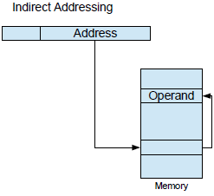

1. It is the register addressing mode and the instruction has the address of register which contains the operand. Register 7’s content is 0x10003013.

So, the answer is 0x10003013.

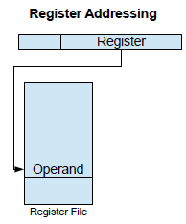

1. It is the register indirect addressing mode and the instruction has the address of register, 7.

Register 7’s content is 0x10003013. And that address’s content is 0x00000010.

So, the answer is 0x00000010.

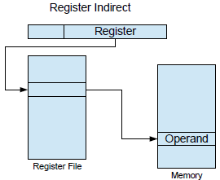

1. The instruction is displacement addressing with register address 20 and offset address as 0xF6.

Register 20 has 0x10003018.

18(hex) + F6(hex)  = 0E

And 1000300E has 0x00000001.

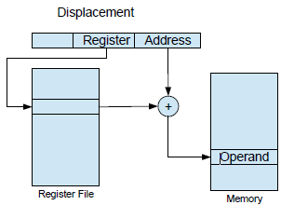

2. A NUMA computer cluster has 200 computing nodes with each node associated with 128GB RAM. Average local memory access time is 50ns and average remote memory access time is 180ns. Assume a program is running on one node in this cluster. It is consuming total of 230GB with local memory occupancy as 100GB. If there are 1 million **(1,000,000)** memory access in this program with probability of accessing a remote memory location as 0.25 what is the total time the program is busy accessing memory in millisecond (ms) unit ? [**10pts**]

ANS)

Local access is 0.75 among 1,000,000 memory access.

1,000,000 * 0.75 * 50 = 37500000ns

Remote access is 0.25 among 1,000,000 memory access.

1,000,000 * 0.25 * 180 = 45000000ns

82500000 ns = 82.5 ms

3. A computing system with traditional disk (rotating hard disk) transfer data to main memory at minimum unit of 2KB of block of data (i.e. it has to adjust read/write head per 2KB block data access). Its average access time is 1ms. It has transfer rate of 100Mbps (mega-bits per second).

Another computing system has solid state disk (with random access technique) transfer data to main memory at minimum unit of 1KB of block of data. It has access time of 50us per block of data transfer and refresh time of 250us. Both the system runs Linux operating system with initial size of 2MB to be loaded into main memory during boot time. Which system will boot faster and how much (ratio their performance)? [**10pts**]

ANS)

a) Hard Disk(rotating) transfer data to main memory 2KB block data ( at minimum).

Avg access time = 1ms

Transfer rate is 100Mbps

b) SSD(random access) transfer 1KB block data.

Access time = 50us per block and refresh time = 250us

Both runs Linux with initial size of 2MB to be loaded into main memory during boot time.

4. Your Project II processor is modified to hook into a cache memory system (i.e. states are introduced to handle cache miss ) and running on 1GHz clock. This system is connected to a memory system with separate instruction and data cache. Both these caches has access time 1ns and cache miss penalty of 150ns. However, miss rate for instruction cache is 5% and miss rate for data cache is 10%. If the following piece of code is executed in that processor and the 'loop' block (starting from 'loop' label to last 'jmp loop') has been executed 10,000 times what is the total execution time of this program so far in 'us' (microsecond) unit? [**10pts**]

ANS)

6*10000 + 3 is total number of instructions

60003 * 5 / 109 = 300.015 us is ideal run time

100010 * 1 * 150ns = 150015ns = 150.015 us is stall time for data cache

600030 * 05 * 150ns = 450022.5ns = 450.0225 us is stall time for instruction cache

Total execution time is 900.0525 us

5. A 32-bit computer system supports 4GB byte addressable memory. It's processor has cache with block size of 1KB. Both the control and tag bits per cache line is 8 bits each. Assume that cache line is fully mapped from bits of the address A excluding block bits and tag bits in the address.

a. How much data is cached within this cache memory in MB unit? [**10pts**]

ANS)

Since TAG is 8bit and block address is 10 bit.

Each cache line has 10KB data.

Number of cache line is 32 – 8 bit – 10bit since the cache line is fully mapped from bits of the address A excluding block bits and tag bits in the address.

214 * 210 byte / 220 byte = **16MB**

b. Also determine actual size of the cache memory in KB unit. [**10pts**]

ANS)

Since control has 8 bit and tag has 8 bit and block address has 10 bit.

32 – (8 + 8 + 10) = 6

So, the number of cache line is 6 bit.

26 * 210 byte = 26 KB = 64 KB

c. Whole memory is divided into how many blocks? [**5pts**]

ANS)

Address / Number of Cache line = Number of blocks

232 / 210 = 222 = 4194304

6. Now, assume that the system in the #5 uses 8-way associative cache but cache same amount of information.

a. Determine TAG, CACHE LINE INDEX and BLOCK INDEX of the address 0x30AB23F2. [5pts]

ANS)

214 / 23 = 211

30AB23F2 = 0011 0000 1010 1011 0010 0011 1111 0010

TAG = 00110000101

CACHE LINE INDEX = 0 1011 0010 00

BLOCK INDEX = 11 1111 0010

b. What is the actual size of the cache memory in this case in KB unit? [5pts]

ANS)

211 * 210 byte = 221 / 210 = 211 KB

7. A 32-bit computer system uses virtual memory with 4K page size. It also uses a cache same as #6. For any memory access, both TLB and cache access time is 1ns each. TLB miss rate is 25% with 20us penalty. Cache miss rate is 10% with 150us penalty. Page fault rate is 0.01% with page service (bring back page from disk to memory) 1s.

a. How much time would be spent for one million (1,000,000) memory access in second unit? [**5pts**]

ANS)

60,0003 is total instructions,

And ideal run time is 1000000 * 2 * 1 ns = 0.002 s,

TLB miss is 1000000 * 0.25 * 20 us = 5 s,

Cache miss is 1000000 * 0.1 * 150 us = 15s,

Page Fault is 1000000 * 1 s= 1000000 s,

So, the Total execution time is 1000120.002 s.

b. Determine TAG, CACHE LINE INDEX and BLOCK INDEX for a virtual address 0x4CD67821 with TLB entry for 0x4CD67 is 0x28701, if this system uses same cache as in #6. [**5pts**]

ANS)

0x4CD67821 = 0100 1100 1101 0110 0111 1000 0010 0001

Block offset is 1000 0010 0001.

Since TLB entry is 0x4CD6

0010 1000 0111 0000 0001 1000 0010 0001

TAG = 00101000011

CACHE LINE INDEX = 10000000110

BLOCK INDEX = 0000100001